**BIOGRAPHY**

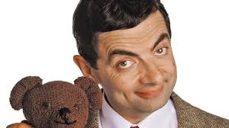

**ROWAN ATKINSON**

**EARLY LIFE**

Rowan Atkinson is a British actor.

He was born in 1955 in Durham, England.

His father was a farmer.

Rowan Atkinson has three older brothers.

Rowan had religious upbring.

He attended the Anglican church.

He was good at Science at school.

He attended Newcastle University.

He obtained a degree in Electrical Engineering at Queen’s College in Oxford.

**MOVIE CAREER**

Rowan Atkinson showed great interest to be in media.

He started off with a series of comedy for BBC Radio.

He first appeared in TV in 1979.

He took on several roles.

His successful and popular series was the „Blackadder“.

He played comical character „Mr. Bean“.

Mr. Bean first appeared on New Year’s Day 1990.

Several sequels appeared on television until 1995.